STAYNEST
PG BOOKING AND MANAGEMENT SYSTEM
USING PHP, HTML,CSS AND JAVASCRIPT

INTERNSHIP REPORT
Submitted in partial fulfillment of the requirements for the award of the degree of
BACHELOR OF SCIENCE IN COMPUTER TECHNOLOGY
at the Bharathiar University

by
HARISHIVANJI P
(Reg. No: 24UGCTE00043)
Under the Guidance of
Dr.D.Geethamani M.Sc., M.Phil., Ph.D.
Assistant Professor
DEPARTMENT OF COMPUTER TECHNOLOGY

DR. N.G.P. ARTS AND SCIENCE COLLEGE
(An Autonomous Institution, Affiliated to Bharathiar University, Coimbatore)
Approved by Government of Tamil Nadu & Accredited by NAAC with A++ Grade (3rd Cycle)
Dr. N.G.P.-Kalapatti Road, Coimbatore-641 048, Tamil Nadu, India.
SEPTEMBER- 2026

DECLARATION
I, HARISHIVANJI P (Reg. No: 24UGCTE00088) hereby declare that the internship report entitled “STAYNEST – PG BOOKING AND MANAGEMENT SYSTEM” submitted in partial fulfillment of the requirement for the award of the degree of Bachelor of Science in Computer Technology at the Bharathiar University is a record of original work done during the period of internship under the supervision and guidance of Dr. D. Geethamani M.Sc., M.Phil., Ph.D., Assistant Professor, Department of Computer Technology, Dr. N.G.P. Arts and Science College, Coimbatore – 48, and it has not formed the basis for the award of any Degree / Diploma / Associateship / Fellowship or other similar title to any candidate of any university.

Place: Coimbatore HARISHIVANJI P
Date: 30.05.2026 (Reg: 24UGCTE00088)

CERTIFICATE
This is to certify that the internship report entitled “STAYNEST – PG BOOKING AND MANAGEMENT SYSTEM” submitted in partial fulfillment of the requirement for the award of the degree of Bachelor of Science in Computer Technology at the Bharathiar University is a record of original work done by HARISHIVANJI P (Reg. No: 24UGCTE00088) during the period (2025–2026) of his study in Department of Computer Technology, Dr. N.G.P. Arts and Science College, Coimbatore – 48 under my supervision and guidance, and the internship report has not formed the basis for the award of any Degree / Diploma / Associateship / Fellowship or other similar title to any candidate of any university.

(Dr. D. Geethamani) (Dr. M. Rathi)
Guide HoD

Place: Coimbatore
Date:

Viva-voce Examination held on: _______________

Internal Examiner External Examiner

INTERNSHIP CERTIFICATE



ACKNOWLEDGEMENT
This internship report was the most significant accomplishment in my life and it would not have been possible without the blessing of God almighty and those who supported and believed in my caliber.
I record my deep sense of gratitude to Dr. NALLA G PALANISWAMI M.D, AB (USA), Chairman, Dr. N.G.P. Research and Educational Trust, Coimbatore for providing me an opportunity to carry out internship successfully.
I record my deep sense of gratitude to Mrs. Mathura V. Palaniswami, Secretary, Dr. N.G.P. Arts and Science College, Coimbatore for providing me an opportunity to carry out internship successfully.
I record my sincere thanks to Dr. S. SARAVANAN M.Com., M.Phil., MBA., Ph.D., Principal, Dr. N.G.P. Arts and Science College, Coimbatore, for every help he rendered before and during the period of project.
I would like to extend my sincere gratitude to Dr. M. Rathi MCA., M.Phil., SET., Ph.D., Professor and Head, Department of Computer Technology, Dr. N.G.P. Arts and Science College, Coimbatore for her constant motivation during my internship.
I record my deep sense of gratitude to the management and team at LITZ Tech for providing me an opportunity to carry out internship in their organization and helping me gain practical exposure towards the industry.
I would like to extend my sincere thanks to my guide Dr.D.Geethamani M.Sc., M.Phil., Ph.D., Assistant Professor, Department of Computer Technology, Dr. N.G.P. Arts and Science College, Coimbatore for her exemplary guidance, encouragement, and sustained interest throughout the period of this work.
I take this opportunity to acknowledge my sincere thanks to all the staff members of the Department of Computer Technology for their constant inspiration, assistance, and resourceful guidance.
I express my sincere thanks to my family and friends for their encouragement, love, advice, and sacrifice without which I would not have been able to pursue the course of this study.

HARISHIVANJI P
(Reg: 24UGCTE00088)

ABSTRACT
StayNest is a web-based PG (Paying-Guest) Booking and Management System developed to make finding, listing and managing paying-guest accommodation faster, easier, and better organized for three kinds of users: students who need a place to stay, PG owners who let out rooms, and a super admin who oversees the whole platform. In a typical PG search, students rely on word of mouth and unverified listings, while owners track rooms and tenants on paper or spreadsheets. StayNest replaces this with a single role-based web application.
The system provides three separate login experiences behind one authenticated session: a student view for browsing and booking PGs, a PG-owner view for managing properties, rooms and beds, and a super-admin view for onboarding owners, approving properties and overseeing bookings and payments platform-wide. Every request is authenticated through PHP sessions and every write action is protected by a CSRF token and a server-side role check, so a user can only reach the screens and actions permitted for their role.
After logging in, a student can search and filter approved PGs by city, gender preference and room type, view full property details, and raise a booking request. A PG owner can add and update their own properties and, for each property, create rooms that automatically generate their beds inside a single database transaction, so a room is never left without its beds. The super admin can view platform-wide students, PG owners, properties, bookings and payments, and — the feature added during this internship — onboard a brand-new PG owner together with their first property in one transaction, or attach an additional property to an owner who already exists.
The application is built with core PHP using a single front-controller router, PDO-backed SQLite storage, and a Bootstrap 5 front end. The report presents the internship activities, system requirements, the application’s modules with screenshots of the running system, the underlying PHP/Bootstrap/SQLite technical foundations, a conclusion, future scope and references.

TABLE OF CONTENTS

CHAPTER NO | TITLE | PAGE NO
I | Introduction | 1
II | Company Profile | 2
III | System Requirements | 2
IV | Internship Activities | 3
V | Application Modules | 5
VI | Application Usage & Technical Foundations | 17
VII | Conclusion | 21
VIII | Future Scope | 22
IX | References | 23

CHAPTER I: INTRODUCTION
The rapid growth of web technology has changed the way everyday services are discovered and managed. Finding Paying-Guest (PG) accommodation is one such everyday service: students and working professionals moving to a new city usually rely on word-of-mouth, unverified listings and paper registers kept by individual PG owners. This makes it hard to compare options, and hard for an owner to keep track of which rooms and beds are actually free.
StayNest is a web-based PG Booking and Management System designed to make this process faster, easier, and better organized. The system allows a student to log in, search and filter PG accommodation, view full property details, and raise a booking request. PG owners can log in to add and update their own properties, and to manage rooms and beds for each property. A super admin oversees the whole platform: reviewing students, onboarding PG owners together with their properties, and monitoring bookings and payments platform-wide.
The system provides three separate role-based views behind one authenticated login: Student, PG Owner and Super Admin. Each role sees only the screens and actions relevant to it, and every state-changing action is protected by session authentication, a server-side role check and a CSRF token. This makes the system safe to use by three very different kinds of users on the same platform.
The application also maintains rooms and beds at a granular level: creating a room automatically generates the requested number of beds inside a single database transaction, so a room can never be left without its beds. By moving PG discovery and property management onto a single organized platform, the system can reduce the friction of finding accommodation for students and the effort of managing occupancy for owners.
The project is developed using core PHP with a single front-controller router, PDO-backed SQLite storage, and a Bootstrap 5 front end. PHP is used to implement routing, authentication, validation and database access; Bootstrap, HTML and CSS provide the structure and visual design of every screen; and small amounts of JavaScript (via Bootstrap’s components) drive inline interactions such as expanding the “Add Property” and “Add Room” forms. The system provides a simple and consistent interface suitable for all three user roles.
CHAPTER II: COMPANY PROFILE
LITZ Tech is an ISO 9001:2015 certified technology solutions and training provider based in Tamil Nadu, specializing in software development, cybersecurity solutions, machine learning integrations, and enterprise IT platforms. For several years, the organization has focused on providing scalable digital solutions while bridging academia and industry through hands-on technical training programs.
The company provides key services including:
- Custom Software & Web Application Development
- Cybersecurity Assessments & Enterprise Infrastructure Setup
- Artificial Intelligence & Machine Learning Integration
- Industrial Internship & Hands-On Technical Skill Training
Address:
LITZ Tech
2X2W+C8F, Access Rd, Peelamedu
Chitra Nagar, Civil Aerodrome Post
Coimbatore, Tamil Nadu 641045.
CHAPTER III: SYSTEM REQUIREMENTS
Hardware Requirements
- Processor: Intel Core i3 / AMD Ryzen 3 or higher
- RAM: Minimum 4 GB (8 GB recommended)
- Storage: 20 GB free space (SSD recommended)
- Network Interface: Standard network adapter with internet access
- Display: 1280 × 720 resolution or higher

Software Requirements
- Operating System: Windows, Linux, or macOS
- Programming Language: PHP 8.x
- Code Editor: Visual Studio Code or any PHP-aware editor
- Technologies: HTML5, CSS3, JavaScript, Bootstrap 5, PHP (PDO), SQLite
- Web Server: PHP built-in development server / Apache (XAMPP)
- Browser: Google Chrome, Microsoft Edge, Mozilla Firefox, or another modern browser
- Version Control: Git / GitHub
CHAPTER IV: INTERNSHIP ACTIVITIES
Date | Day | Work Done
14-May-26 | Thursday | Orientation on Company, Project Requirements & Visual Studio Code Environment Setup
15-May-26 | Friday | PHP Fundamentals – Variables, Control Structures, Functions and Arrays
16-May-26 | Saturday | Front-Controller Routing – Studying public/index.php and Path-Based Dispatch
18-May-26 | Monday | Database Connectivity – PDO, Prepared Statements and a Singleton Database Class
19-May-26 | Tuesday | Session-Based Authentication – Login, Password Hashing and Logout
20-May-26 | Wednesday | Role-Based Access Control – Guarding Routes for Student, PG Owner and Super Admin
21-May-26 | Thursday | CSRF Protection & Form Validation Across Every State-Changing Form
22-May-26 | Friday | Student Module – PG Search, Filters, PG Details and Booking Requests
23-May-26 | Saturday | PG Owner Module – Property Create/Update Forms and an Owner Dashboard
25-May-26 | Monday | Room & Bed Management – Transactional Room Creation with Auto-Generated Beds
26-May-26 | Tuesday | Super Admin Module – Dashboard, Student Management and Platform List Views
27-May-26 | Wednesday | Admin Owner & PG Onboarding – Creating an Owner with Their First Property Together
28-May-26 | Thursday | Functional Testing – Login, CSRF Protection, Role Guards and Room/Bed Creation
29-May-26 | Friday | Bug Fixing, UI Refinements & Documentation Preparation
30-May-26 | Saturday | Final Review, Project Demonstration & Internship Completion
CHAPTER V: APPLICATION MODULES
StayNest is divided into modules across three roles — Student, PG Owner and Super Admin — to keep the food-ordering-style simplicity of a small application while still separating each role’s concerns cleanly. Each module performs a specific function in the platform, and every screenshot below was captured directly from the running application.
1. Login Module
The Login Module provides a single authenticated entry point for all three roles. A user submits their email and password; StayNest verifies the password hash, confirms the account is active, and redirects to the correct dashboard for that user’s role (Student, PG Owner or Super Admin) — all from the same form.
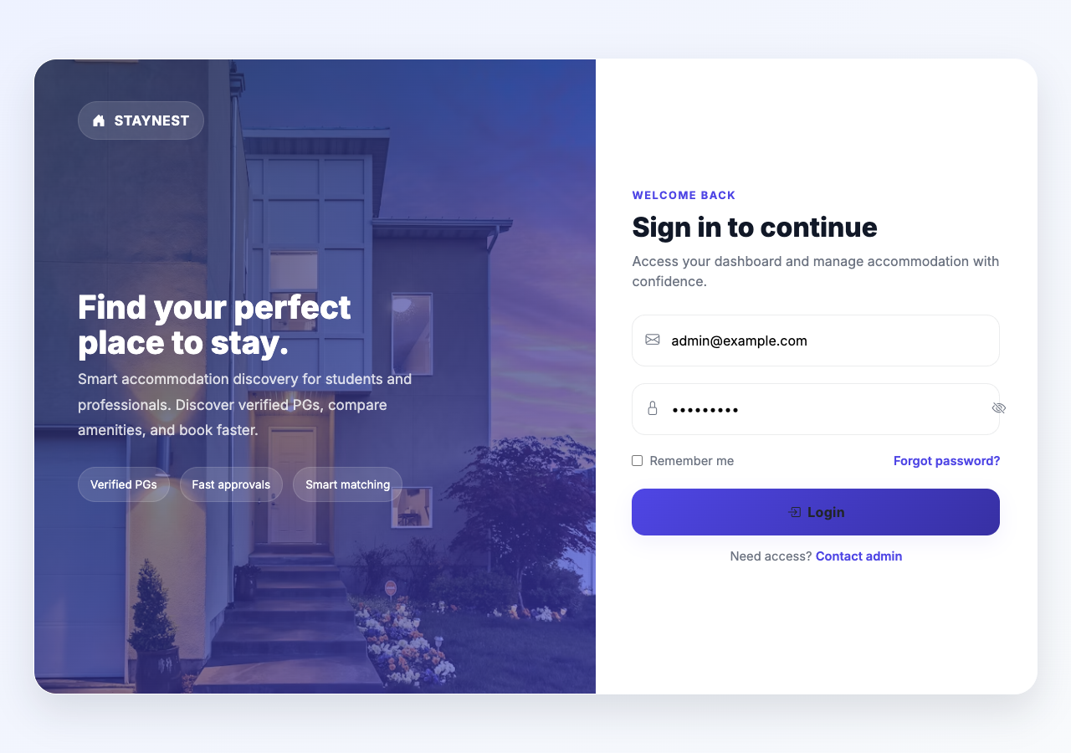
Fig 1: StayNest login screen.
2. Student Dashboard Module
After a student logs in, the Student Dashboard summarises the account and gives quick access to search, bookings and profile management.
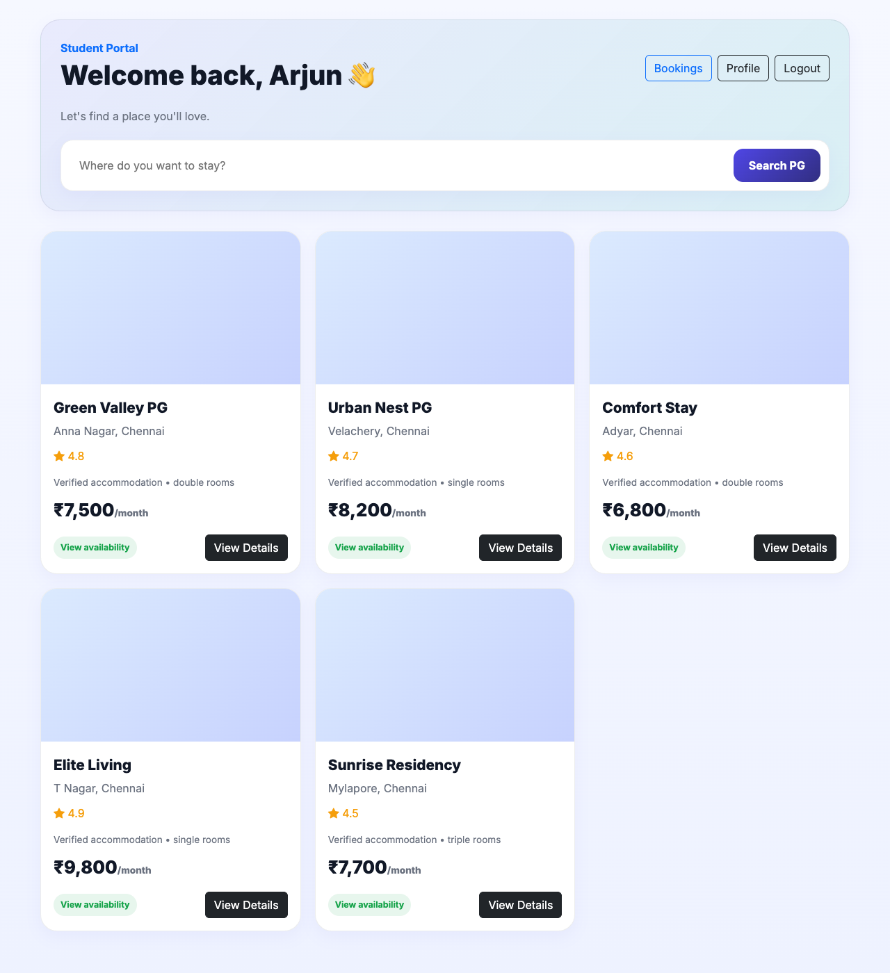
Fig 2: Student dashboard.
3. PG Search & Discovery Module
The Search module lets a student filter approved, active PGs by free-text query, gender preference, room type and maximum price, returning matching properties as cards.
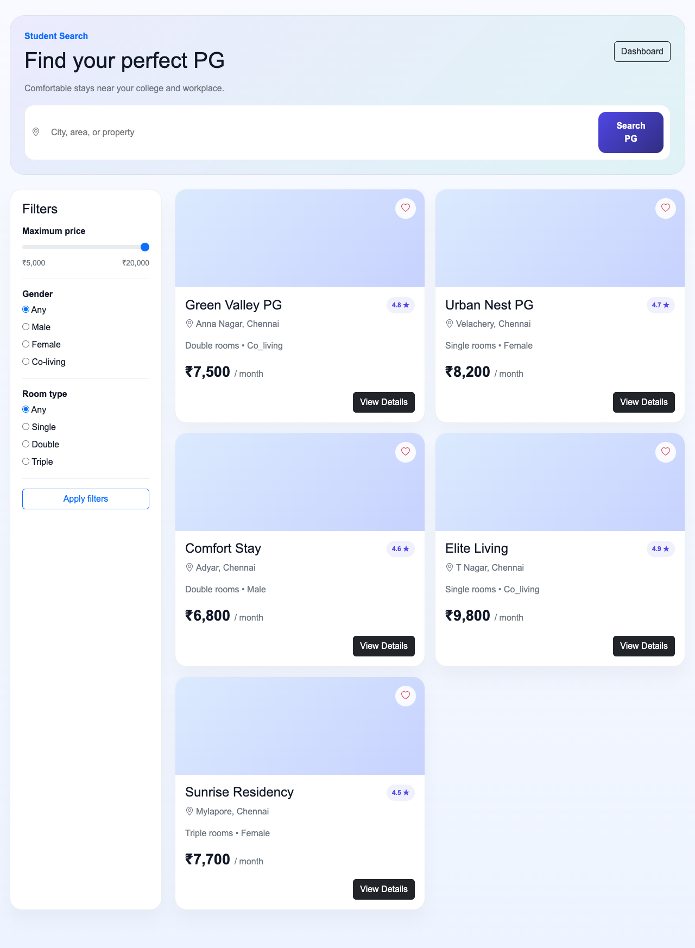
Fig 3: PG search and filtering.
4. PG Details & Booking Request Module
Selecting a property opens its detail page — address, pricing, gender and room-type information — with a button that raises a booking request tied to that student and PG.
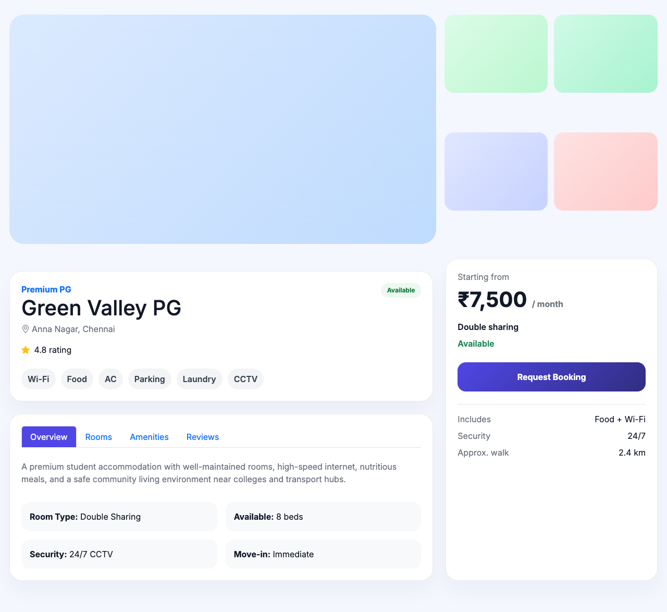
Fig 4: PG detail and booking-request view.
5. Student Bookings Module
The Bookings module lists every booking request a student has made along with its current status (pending, active or completed).
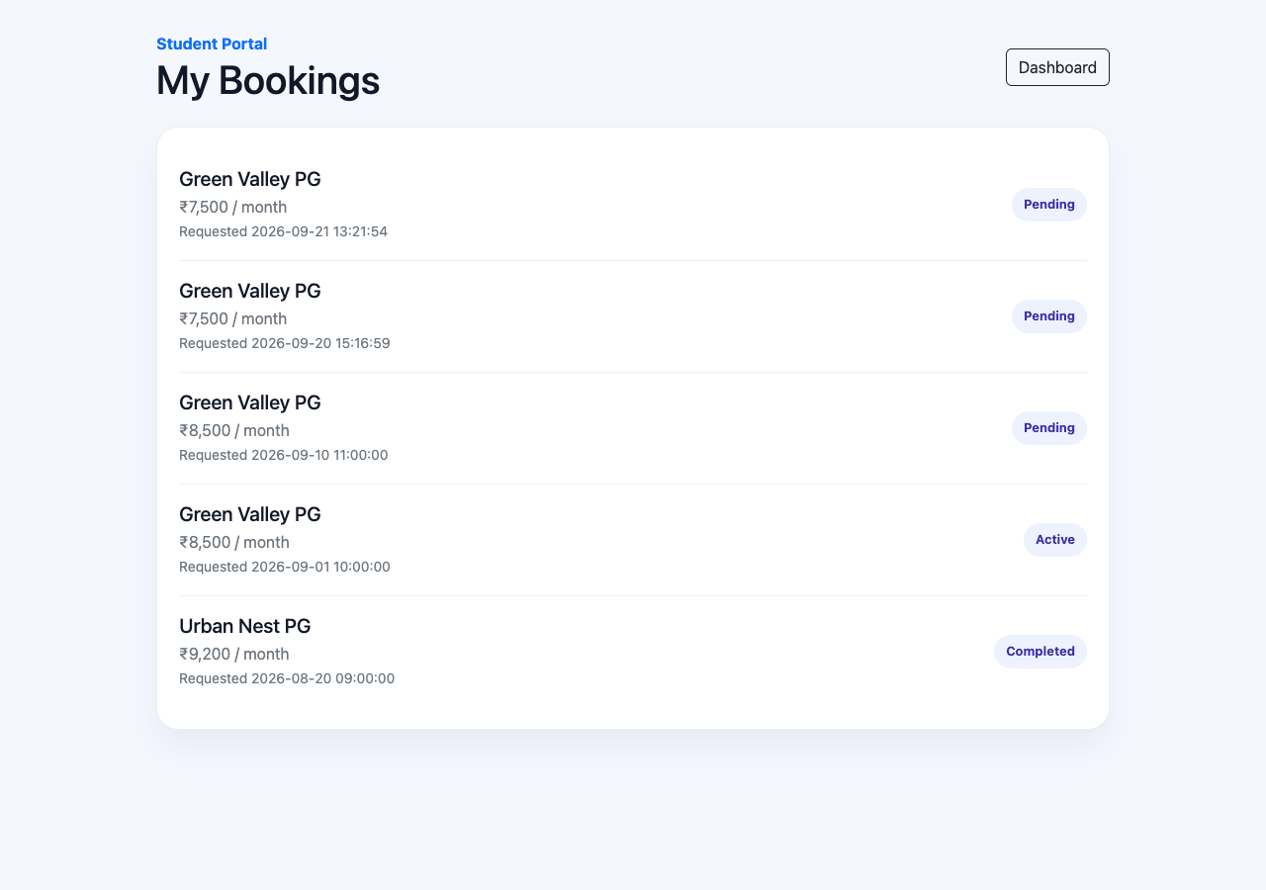
Fig 5: Student bookings list.
6. Student Profile Module
Students can view and edit their name and email from the Profile module, with changes written back to the session immediately after a successful update.
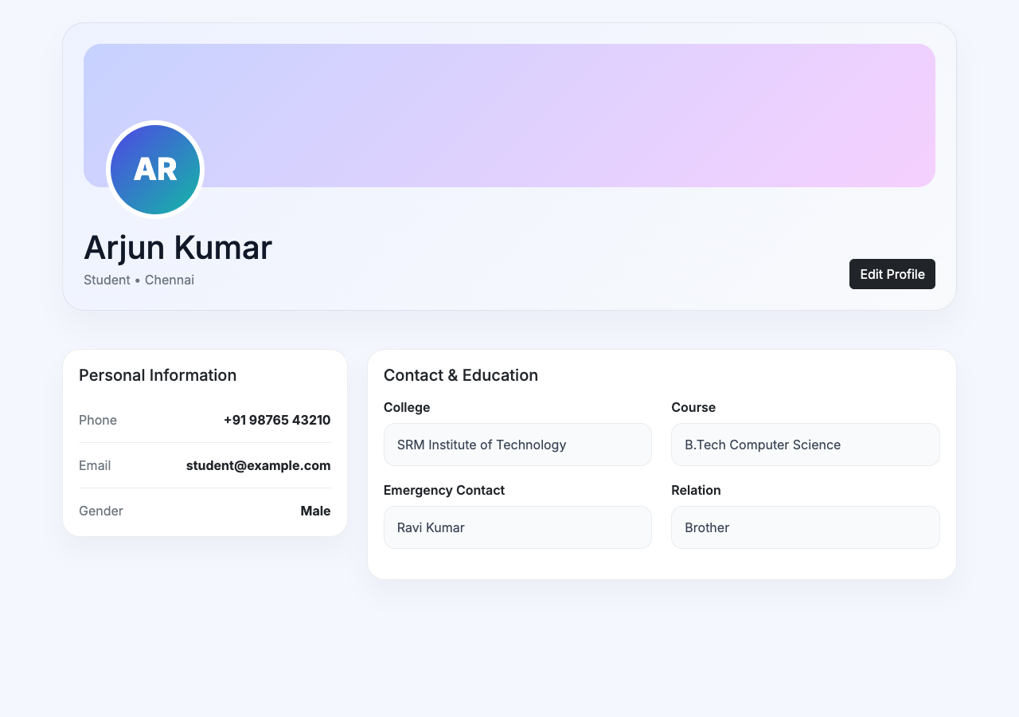
Fig 6: Student profile.
7. PG Owner Dashboard Module
The PG Owner Dashboard summarises the owner’s portfolio: total properties, total beds and occupied beds, giving an at-a-glance occupancy picture.
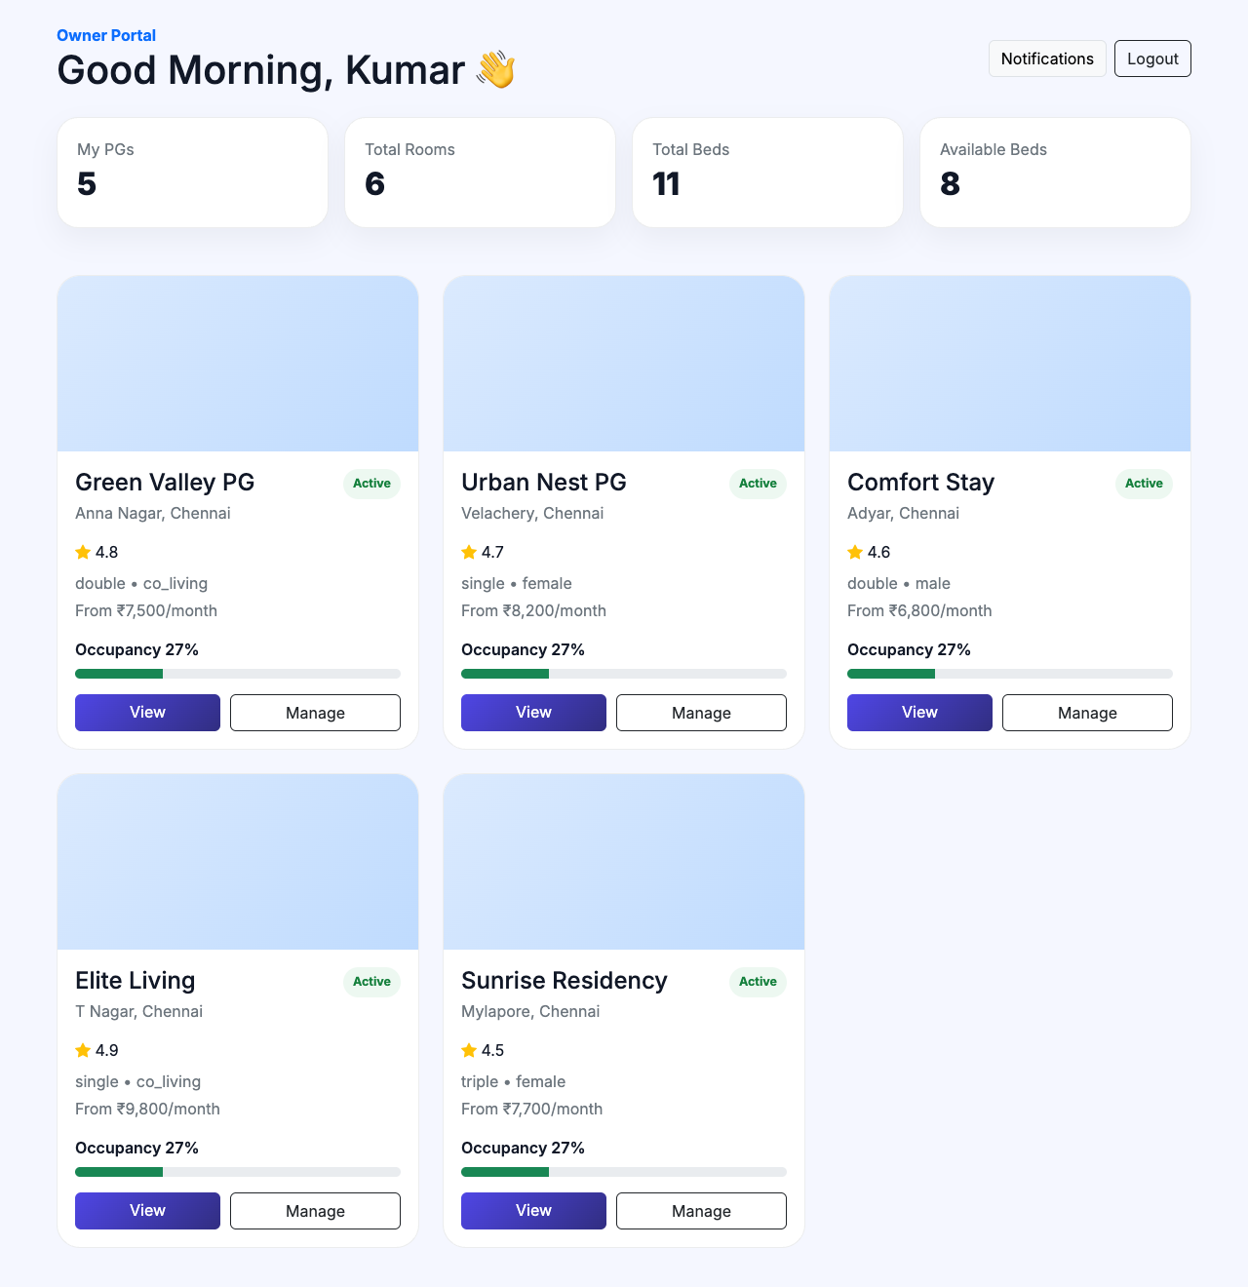
Fig 7: PG owner dashboard.
8. Property Management Module
PG owners can submit a new property or edit an existing one through an inline form, and see every property they own as a card with occupancy, rent and status.
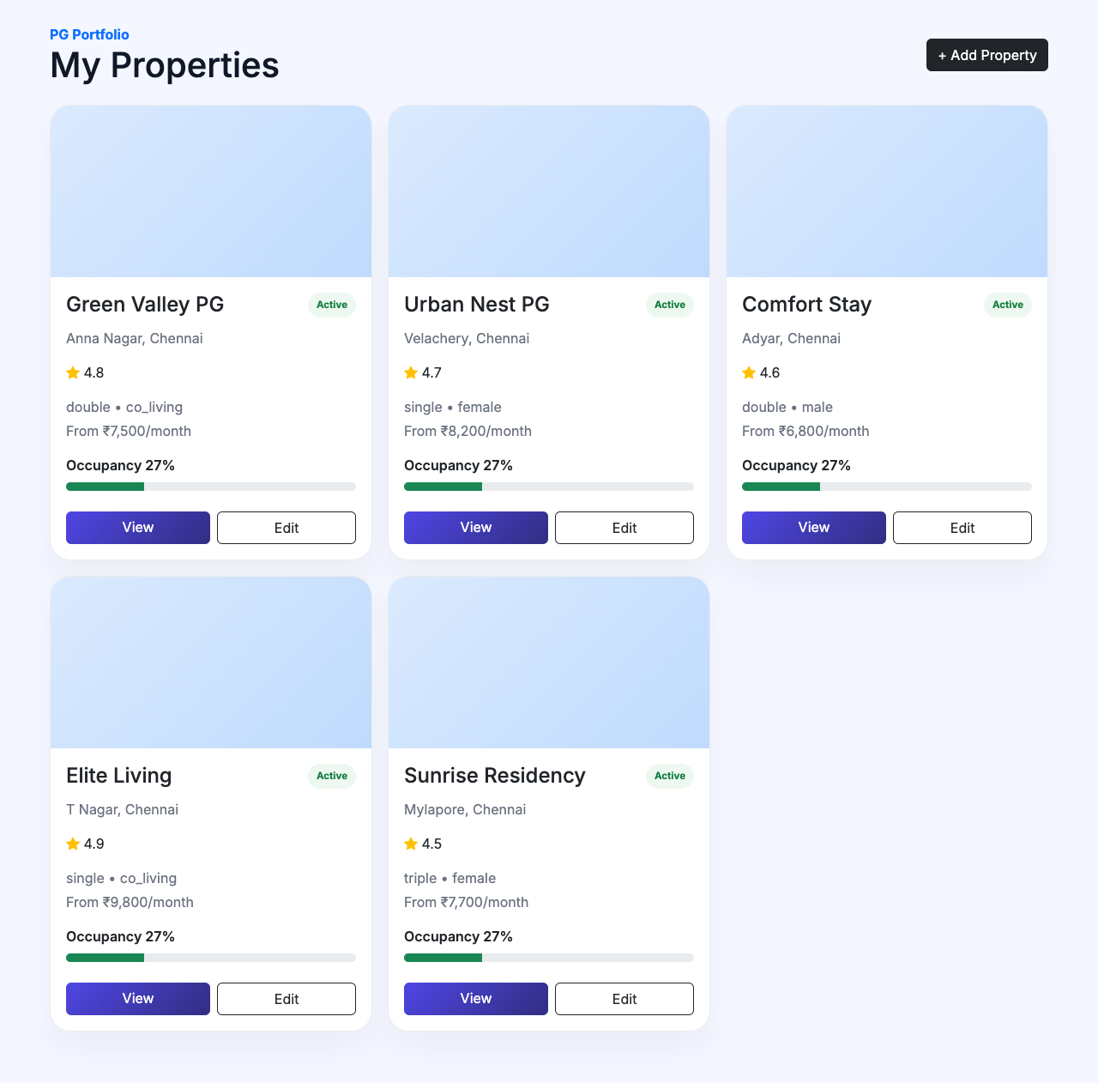
Fig 8: My Properties – property management.
9. Room & Bed Management Module
For each property, an owner can add a room with a room number, type, rent and bed count. StayNest automatically creates the matching bed rows (A, B, C …) inside a database transaction, and each room card shows live availability per bed.
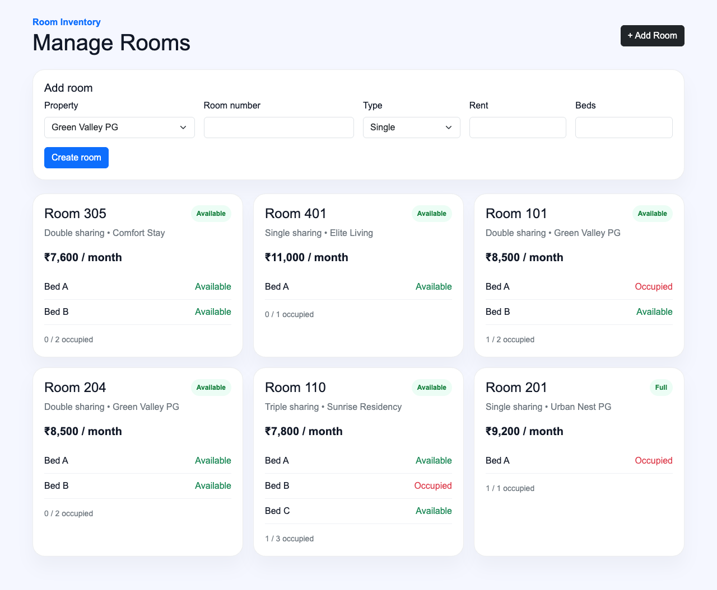
Fig 9: Room and bed management.
10. Super Admin Dashboard Module
The Super Admin Dashboard gives a platform-wide summary — students, PG owners, properties, bookings and payments — and links into every management section.
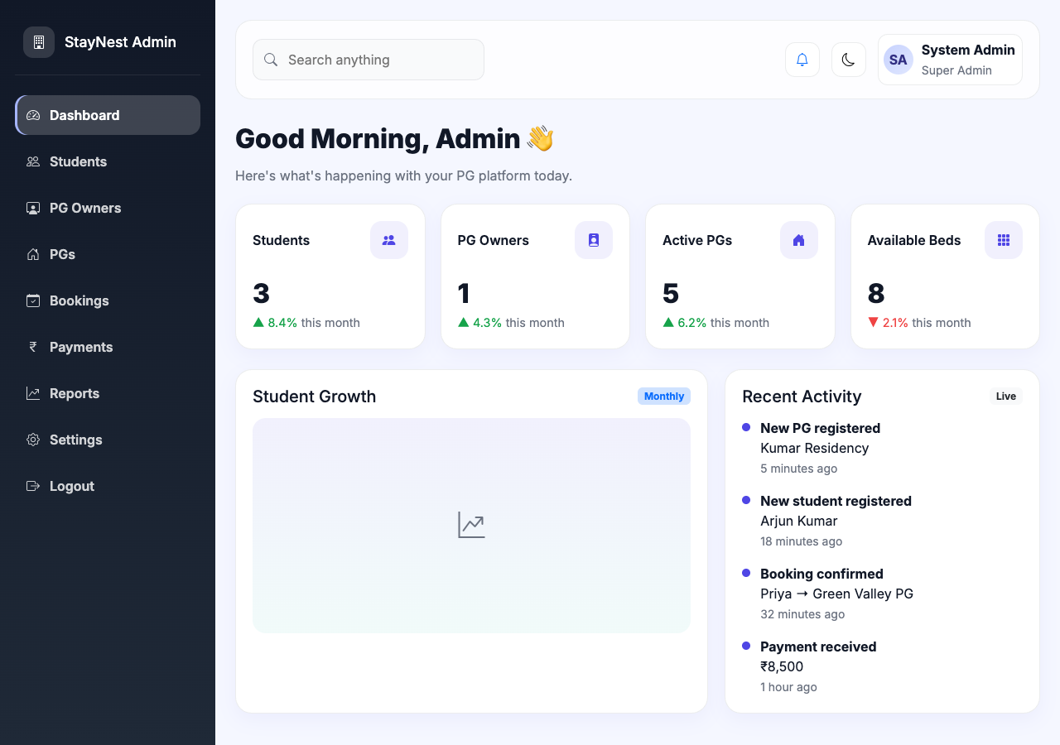
Fig 10: Super admin dashboard.
11. Student Management Module (Admin)
The super admin can view every student account, create new student accounts, and activate or deactivate a student from a single screen.
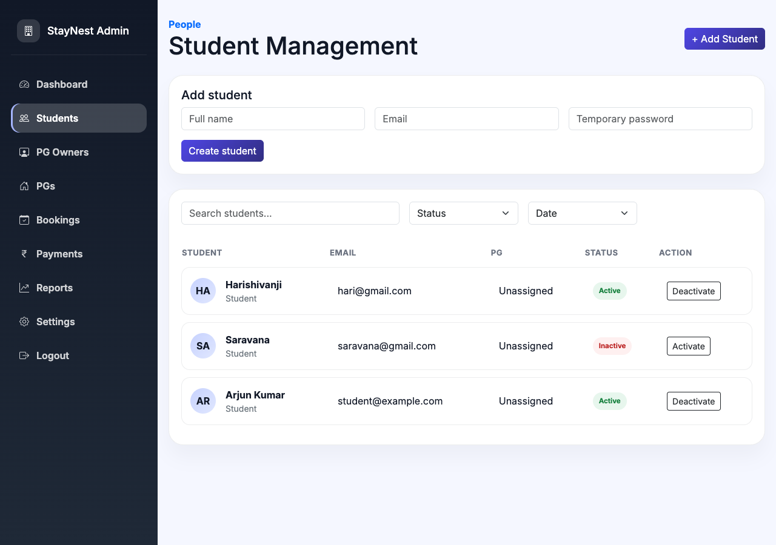
Fig 11: Admin – student management.
12. PG Owner Onboarding Module (Admin)
This module was built during the internship: the super admin can create a brand-new PG owner account together with their first property in a single transaction, and the list view shows every owner alongside the properties currently linked to them.
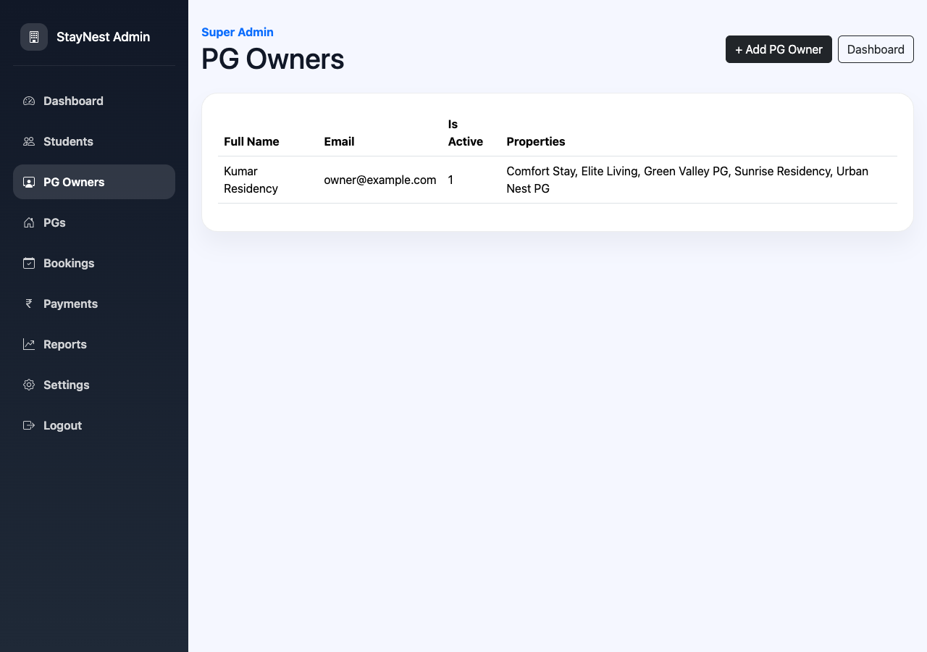
Fig 12: Admin – PG owner onboarding.
13. Property Assignment Module (Admin)
The admin PGs screen lists every property on the platform and lets the super admin attach an additional property to an existing PG owner, without needing to create a new owner account each time.
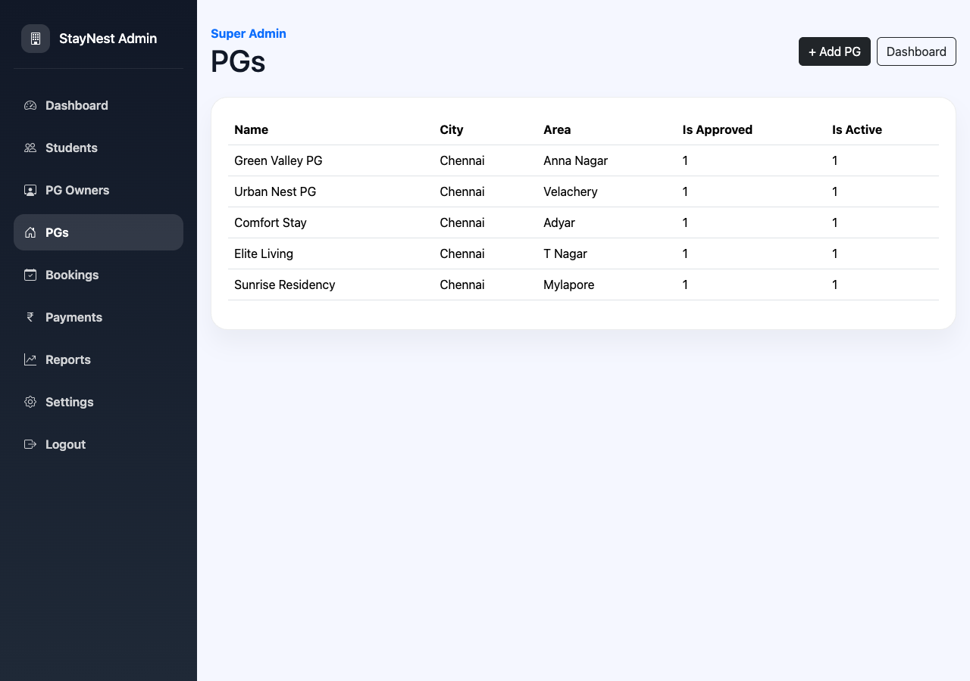
Fig 13: Admin – property assignment.
CHAPTER VI: APPLICATION USAGE & TECHNICAL FOUNDATIONS
StayNest is developed using core PHP, PDO-backed SQLite storage, and a Bootstrap 5 front end to create a secure, role-based, multi-user web application. Visual Studio Code is used as the primary development environment. The application allows students, PG owners and a super admin to log in, manage PG properties, rooms and beds, and raise or track bookings, all behind session authentication, server-side role checks and CSRF protection.

1. PHP – Front Controller & Routing
A single front controller (public/index.php) reads the request path and dispatches to the matching view, after checking the logged-in user’s role.

Route Example – Room Creation
if ($path === 'owner/room/create' && $_SERVER['REQUEST_METHOD'] === 'POST') {
Auth::requireRole(['pg_owner']);
if (verify_csrf() && (int) ($_POST['pg_id'] ?? 0) > 0
&& trim((string) ($_POST['room_number'] ?? '')) !== '') {
PG::createRoom((int) $_POST['pg_id'], (int) current_user()['id'], [
'room_number' => trim($_POST['room_number']),
'room_type' => $_POST['room_type'] ?? 'double',
'rent' => (float) ($_POST['rent'] ?? 0),
'beds_total' => max(1, (int) ($_POST['beds_total'] ?? 1)),
]);
set_flash('success', 'Room and beds created.');
}
redirect('/owner/rooms');
}

The route reads the request path and method, delegates to a model method for the actual database work, and redirects back with a flash message describing the result.
2. PHP – Session-Based Authentication
Login is handled by a small Auth class. It looks up the user by email, verifies the password hash, confirms the account is active, and stores the user in the PHP session.

public static function login(string $email, string $password): bool
{
$user = User::findByEmail($email);
if (!$user || !password_verify($password, $user['password_hash'])) {
return false;
}
if ((int) ($user['is_active'] ?? 0) !== 1) {
return false;
}
Session::set('user', [
'id' => (int) $user['id'], 'name' => $user['full_name'],
'email' => $user['email'], 'role' => $user['role'],
]);
Session::regenerate();
return true;
}

Role Guard
public static function requireRole(array $roles): void
{
$currentRole = current_user_role();
if (!$currentRole || !in_array($currentRole, $roles, true)) {
redirect('/login');
}
}

Every protected route calls Auth::requireRole() with the roles allowed to access it, so access control is enforced on the server for every request, not only hidden in the UI.
3. Database – PDO & SQLite
StayNest stores data in a single SQLite file accessed through PDO with prepared statements. The core schema models properties, rooms and beds as related tables:

CREATE TABLE pgs (
id INTEGER PRIMARY KEY AUTOINCREMENT,
owner_id INTEGER, name TEXT NOT NULL, city TEXT, area TEXT, address TEXT,
price_from REAL DEFAULT 0, gender TEXT, room_type TEXT,
is_approved INTEGER DEFAULT 0, is_active INTEGER DEFAULT 1,
rating REAL DEFAULT 4.5, created_at TEXT DEFAULT CURRENT_TIMESTAMP
);

CREATE TABLE rooms (
id INTEGER PRIMARY KEY AUTOINCREMENT, pg_id INTEGER,
room_number TEXT, room_type TEXT, rent REAL, beds_total INTEGER,
status TEXT DEFAULT "active"
);

CREATE TABLE beds (
id INTEGER PRIMARY KEY AUTOINCREMENT, room_id INTEGER,
bed_number TEXT, status TEXT DEFAULT "available",
student_id INTEGER NULL, created_at TEXT DEFAULT CURRENT_TIMESTAMP
);

Transactional Room & Bed Creation
Creating a room and its beds together must either fully succeed or fully fail, so the write is wrapped in a PDO transaction:

$pdo->beginTransaction();
try {
$room = $pdo->prepare('INSERT INTO rooms
(pg_id, room_number, room_type, rent, beds_total, status)
VALUES (:pg_id, :room_number, :room_type, :rent, :beds_total, "active")');
$room->execute([...]);
$roomId = (int) $pdo->lastInsertId();

$bed = $pdo->prepare('INSERT INTO beds
(room_id, bed_number, status) VALUES (:room_id, :bed_number, "available")');
for ($index = 1; $index <= (int) $data['beds_total']; $index++) {
$bed->execute(['room_id' => $roomId, 'bed_number' => chr(64 + $index)]);
}
$pdo->commit();
} catch (Throwable $exception) {
$pdo->rollBack();
throw $exception;
}

The bed_number is derived with chr(64 + $index), producing A, B, C … for each bed in the room.
4. Front-End – HTML, CSS & Bootstrap 5
HTML provides the structure of the login page and every role’s dashboard. Bootstrap 5 supplies the grid, cards, tables, badges and form controls, while a small amount of custom CSS adjusts colours, radii and shadows to give StayNest its own look.

<div class="d-flex justify-content-between align-items-center mb-4">
<div>
<div class="text-primary fw-bold">Super Admin</div>
<h1 class="mb-0">PG Owners</h1>
</div>
<button class="btn btn-dark" data-bs-toggle="collapse"
data-bs-target="#ownerForm">+ Add PG Owner</button>
</div>

This markup is repeated — with different content — across the student, PG-owner and admin views, giving every screen a consistent visual language of cards, badges and progress bars for occupancy.
5. JavaScript – Bootstrap Interactivity
StayNest keeps client-side JavaScript minimal, relying on Bootstrap’s bundled components for interaction. The data-bs-toggle="collapse" attribute above expands and collapses the “Add Property” and “Add Room” forms without a full page reload, using Bootstrap’s own JavaScript bundle.

CSRF Token Embedded in Every Form
function csrf_field(): string
{
return '<input type="hidden" name="_csrf" value="'
. e(csrf_token()) . '">';
}

Every state-changing form in the application includes this hidden field, and the server rejects the submission with verify_csrf() if the token is missing or does not match the session.
Visual Studio Code
Visual Studio Code is used as the primary development environment for editing the PHP, HTML, CSS and JavaScript files. It provides syntax highlighting, PHP IntelliSense, error detection, file management and Git integration. PHP’s built-in development server (php -S) is used to preview and test the application locally in the browser while developing.
Responsive Web Design
Bootstrap’s responsive grid and utility classes make the login form, dashboards, property cards, and room/bed cards adjust to the available screen width. This lets StayNest work comfortably on desktop and tablet screens without a separate mobile layout.
Client-Side vs Server-Side Processing
Validation and business rules — required fields, CSRF checks, ownership checks, numeric constraints — are enforced on the server in PHP so they cannot be bypassed. Bootstrap’s JavaScript is used only for presentation-level interaction such as expanding forms and toggling password visibility, keeping the security-relevant logic entirely server-side.
External Library Integration
The project integrates Bootstrap 5 and Bootstrap Icons through CDN links (cdn.jsdelivr.net), giving every screen a consistent, professional appearance without bundling a front-end build step into the PHP project.
CHAPTER VII: CONCLUSION
StayNest provides a simple and efficient solution for discovering and managing Paying-Guest accommodation. The system allows students, PG owners and a super admin to access the platform through separate, role-based logins and to carry out exactly the actions relevant to their role, behind a single authenticated session.
The application provides important features such as PG search and filtering, property detail views, booking requests, property create/update forms, transactional room and bed creation, occupancy tracking, and a super-admin workflow that onboards a PG owner together with their first property in a single step. These features help reduce the friction of finding accommodation and the effort of tracking occupancy, and keep the platform’s data consistent even when several rows must be written together.
The project was developed using core PHP, PDO-backed SQLite storage, and a Bootstrap 5 front end. PHP provides routing, authentication, validation and data access; Bootstrap, HTML and CSS provide the structure, styling and responsive layout of every screen; and CSRF tokens together with server-side role checks protect every write. The project demonstrates how a small set of well-understood web technologies can be combined into a secure, multi-role, real-world application.
Overall, StayNest improves convenience for students looking for accommodation and gives PG owners and the platform administrator organized tools to manage properties, rooms, beds, bookings and payments. With further development, the system can be extended with online payments, richer reporting, and notification features, providing a strong foundation for a modern PG management platform.
CHAPTER VIII: FUTURE SCOPE
StayNest provides a convenient way for students to discover PG accommodation and for owners and the platform administrator to manage it. The system can be further improved with the following features:
1. Online Payments
Real UPI, card and net-banking payment gateways can be integrated so that booking deposits and monthly rent can be collected directly through the platform instead of being tracked manually.
2. Review & Rating Moderation
The existing reviews table can be surfaced in the UI with a moderation workflow, letting students rate a PG after a stay and letting the super admin approve or remove reviews.
3. Richer Admin Reporting
The Reports and Settings sections currently reserved in the admin sidebar can be built out into occupancy trends, revenue summaries, and exportable reports for the platform administrator.
4. Notifications
The existing notifications table can be extended to send email or SMS alerts for booking confirmations, payment reminders and property approvals, instead of only being visible inside the dashboard.
5. Booking Status Workflow
Booking requests can be extended with an explicit approve/reject workflow so PG owners can respond to a student’s request and the student can track its status in real time.
6. Mobile-Friendly Progressive Web App
The existing Bootstrap-based responsive design can be packaged as a installable progressive web app so students and owners can use StayNest comfortably from a phone.
7. Automated Testing
A PHPUnit test suite can be added around the model layer (User, PG, Booking) to catch regressions in authentication, CSRF handling and the transactional room/bed creation logic as the project grows.
Overall, these improvements can make StayNest more complete, more automated, and more convenient for students, PG owners and the platform administrator alike.
CHAPTER IX: REFERENCES
BOOK REFERENCES:
- Welling, L., & Thomson, L. (2016). PHP and MySQL Web Development (5th ed.). Addison-Wesley.
- Zandstra, M. (2013). PHP Objects, Patterns, and Practice (5th ed.). Apress.
- Nixon, R. (2018). Learning PHP, MySQL & JavaScript: With jQuery, CSS & HTML5 (5th ed.). O’Reilly Media.
- Duckett, J. (2011). HTML and CSS: Design and Build Websites. John Wiley & Sons.
- Duckett, J. (2014). JavaScript and JQuery: Interactive Front-End Web Development. John Wiley & Sons.
- Flanagan, D. (2020). JavaScript: The Definitive Guide (7th ed.). O’Reilly Media.
- McFarland, D. S. (2014). CSS3: The Missing Manual (3rd ed.). O’Reilly Media.
WEB REFERENCES:
- PHP Manual – https://www.php.net/manual/en/
- PHP PDO Documentation – https://www.php.net/manual/en/book.pdo.php
- Bootstrap Documentation – https://getbootstrap.com/docs/5.3/
- SQLite Documentation – https://www.sqlite.org/docs.html
- MDN Web Docs – HTML, CSS, JavaScript and HTTP references – https://developer.mozilla.org/
- Git Documentation – https://git-scm.com/doc
- OWASP CSRF Prevention Cheat Sheet – https://cheatsheetseries.owasp.org/

